Question 2

Manually configure static routes on a router to direct packets to different subnets.

Use the ip route command and verify connectivity using ping and traceroute.

Approach

Create a simple network shown below

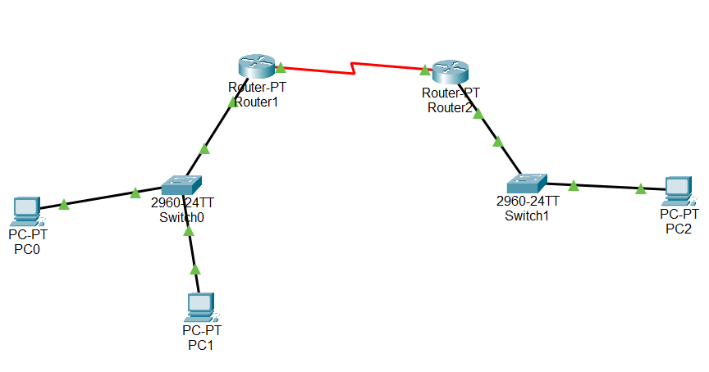

Now try to ping the pc under same subnet. You can able to ping. But if you try to ping the device in different network, you can’t

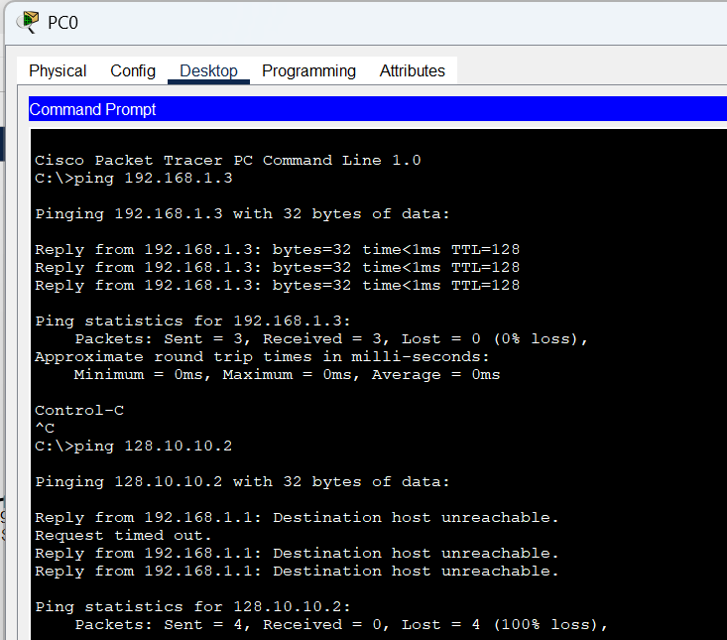

Now using ip route command try to add route to the router

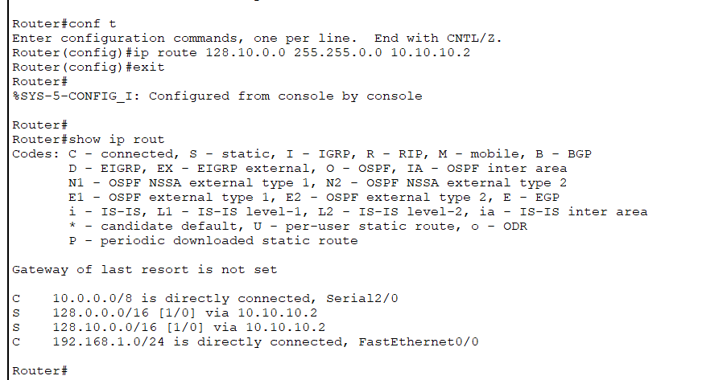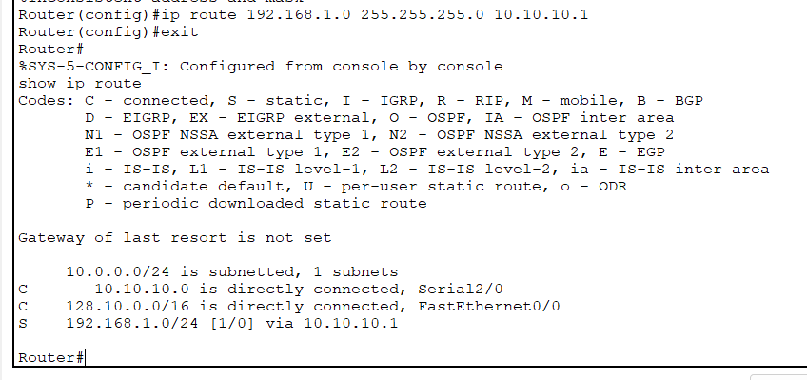

After creating the route, now we can able to successfully ping the another system in different network.

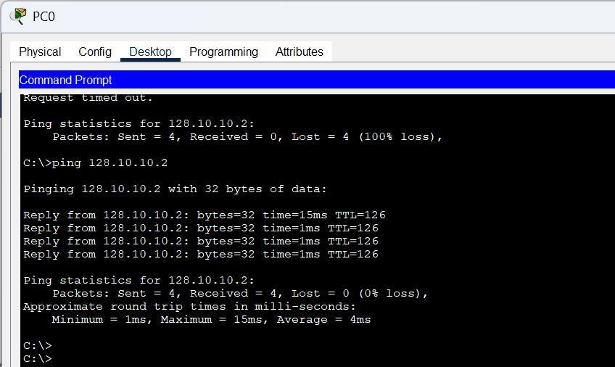

By using tracert command we get the hops it travel to reach the desire pc

